Handout 5
Introduction to Programming in C++
Deadline is
November 28 (Tuesday’s Course)
November 30 (Thursday’s Course)

Exercise 1: Given the following C++ code:
class A {
public :
int x;
A *objARef;
private :
int y;
protected :
int z;
};
class B : public A {
public :
A objA;
};
class C {
public :
A objA;
A *objARef;
B objB;
};

Determine for each of the following attribute-access-expressions whether it results in an Error (Wrong) or not (OK).

 | in class A | in class B | in class C
x | 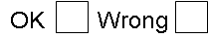
y
z
objA.x
objA.y
objA.z
objARef->x
objARef->y
objARef->z
objB.x
objB.y
objB.z

Exercise 2:
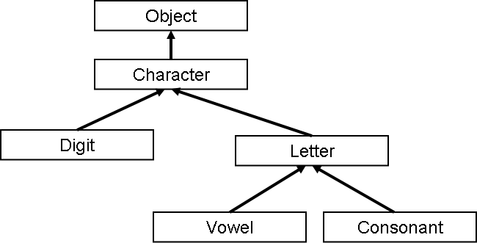
Given the following class hierarchy:

1. Create C++ code without attributes and methods for all for all 6 classes.

2. Extend the class character by a public attribute ch, so that it can store a single character.

3. Overload the operator + for the class Character, so that it can add two objects of type Character. (Implement the +, by using the numeric ASCII-codes)

4. Override the operator + in the Digit class, so that it adds the numeric value of two digits and delivers the digit that we get if we finally apply “modulo 10”.
(Example ‘5’ + ‘6’ = ‘1’ // 5 + 6 = 11 % 10 = 1)

5. Extend the Object class by an object counter that counts the number of created objects for all objects of the above class hierarchy. (Tip: Lecture 9 slide 5) The counter should be embedded into the Object-class default constructor.

6. Change the visibility of the attribute ch, so that it is visible in all subclasses, but inaccessible from outside. Create a get-set method pair for the attribute ch.

7. Create a main-method, where you create 2 objects of each class in the above class hierarchy and that prints finally the value of your object counter (this should be 10).

